**CHAROTAR UNIVERSITY OF SCIENCE AND TECHNOLOGY (CHARUSAT),**

**CHANGA – 388 421**

**Chandubhai S. Patel Institute of Technology**

**V .T. Patel Department of Electronics and Communications Engineering**

**Report for Expert Talk**

**Date: 01-09-2023**

# Date: September 1, 2023

**No.of Participants:45**

Organized by: Mrs. Arpita P. Patel

**Resource Person:** Mr.Jaydeep Padariya,Parth Ardesana,Prerak Dalia and Nilay soni

**Type:** Expert talk

**Title:** VLSI Career Success Stories & Industry Outlook

**Date and Time:** 01-09-2023, 01:00 AM to 3:30 pm. (2.50Hours),

**Summary/Topics covered in Expert Talk:**

* Introduction to ASIC flow, Journey of a chip
* Job opportunities for PD, DFT and verification engineer
* Overview of verification, Pre silicon verification flow

**Photograph:**  Expert talk Photographs with date and caption

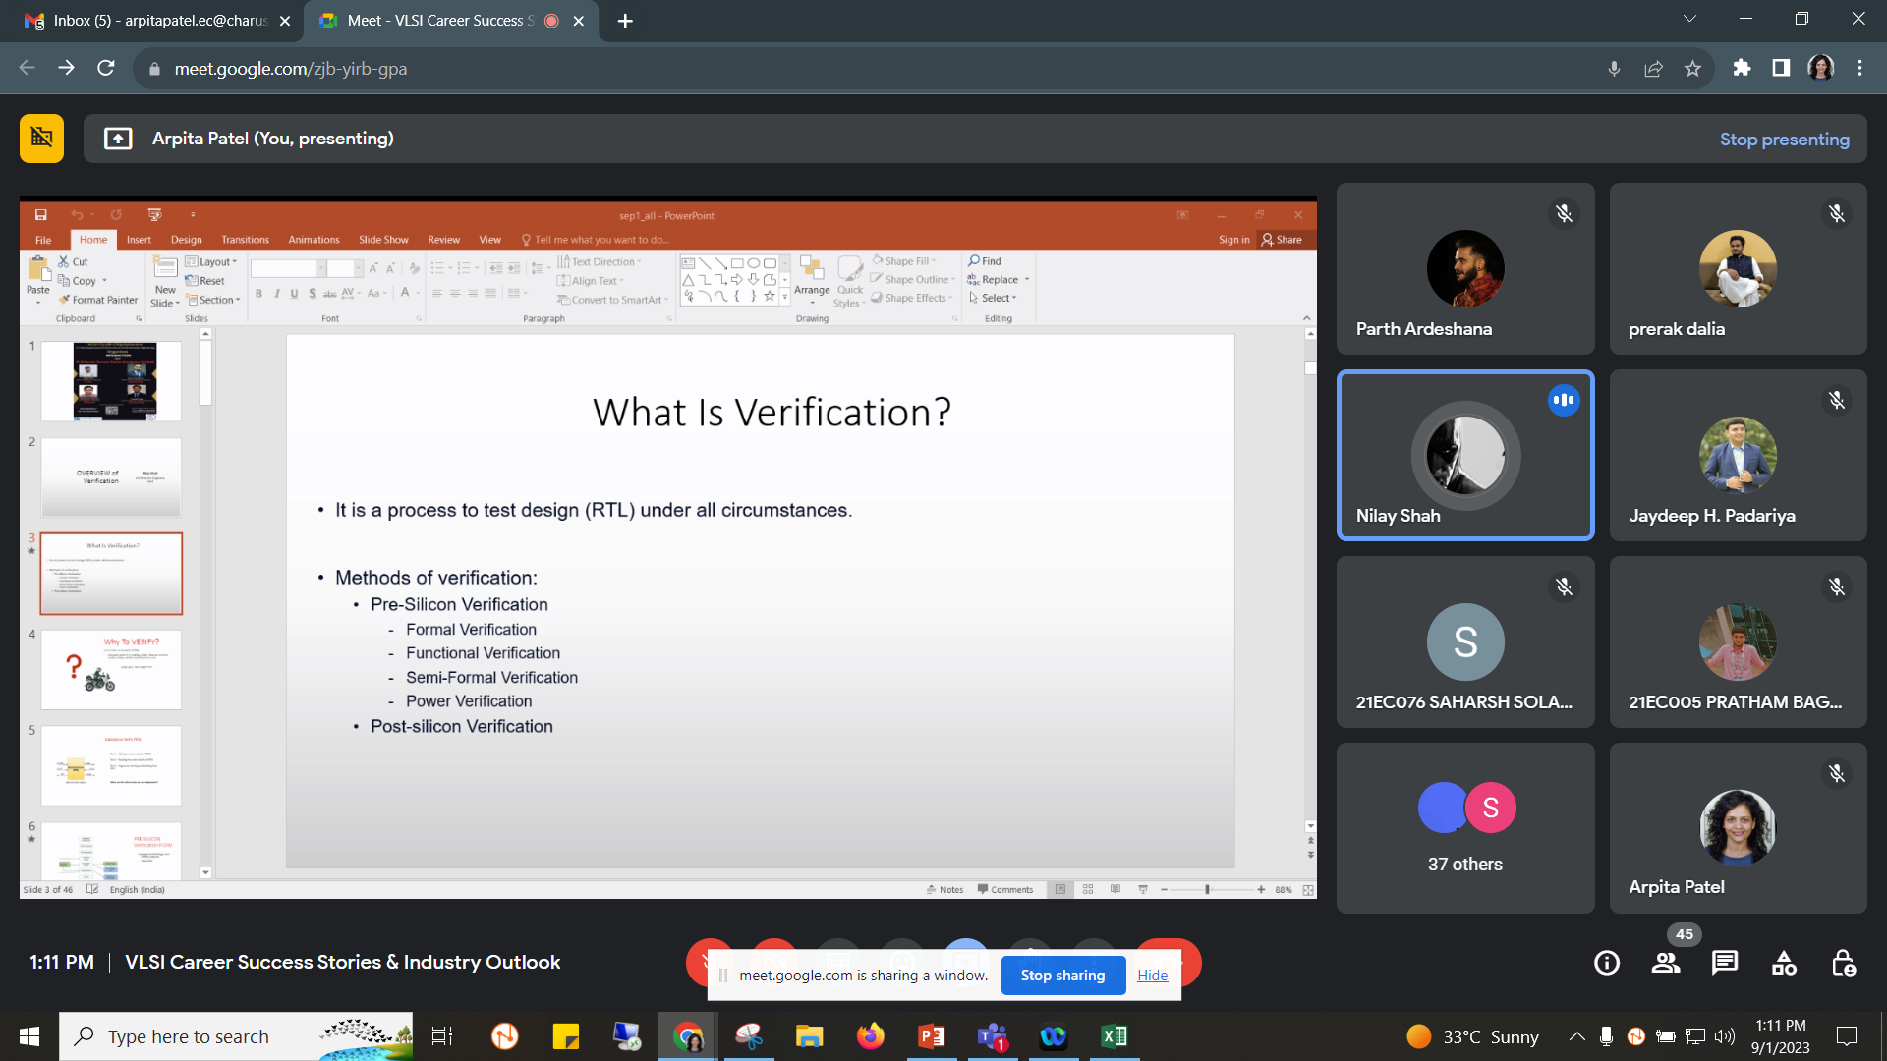

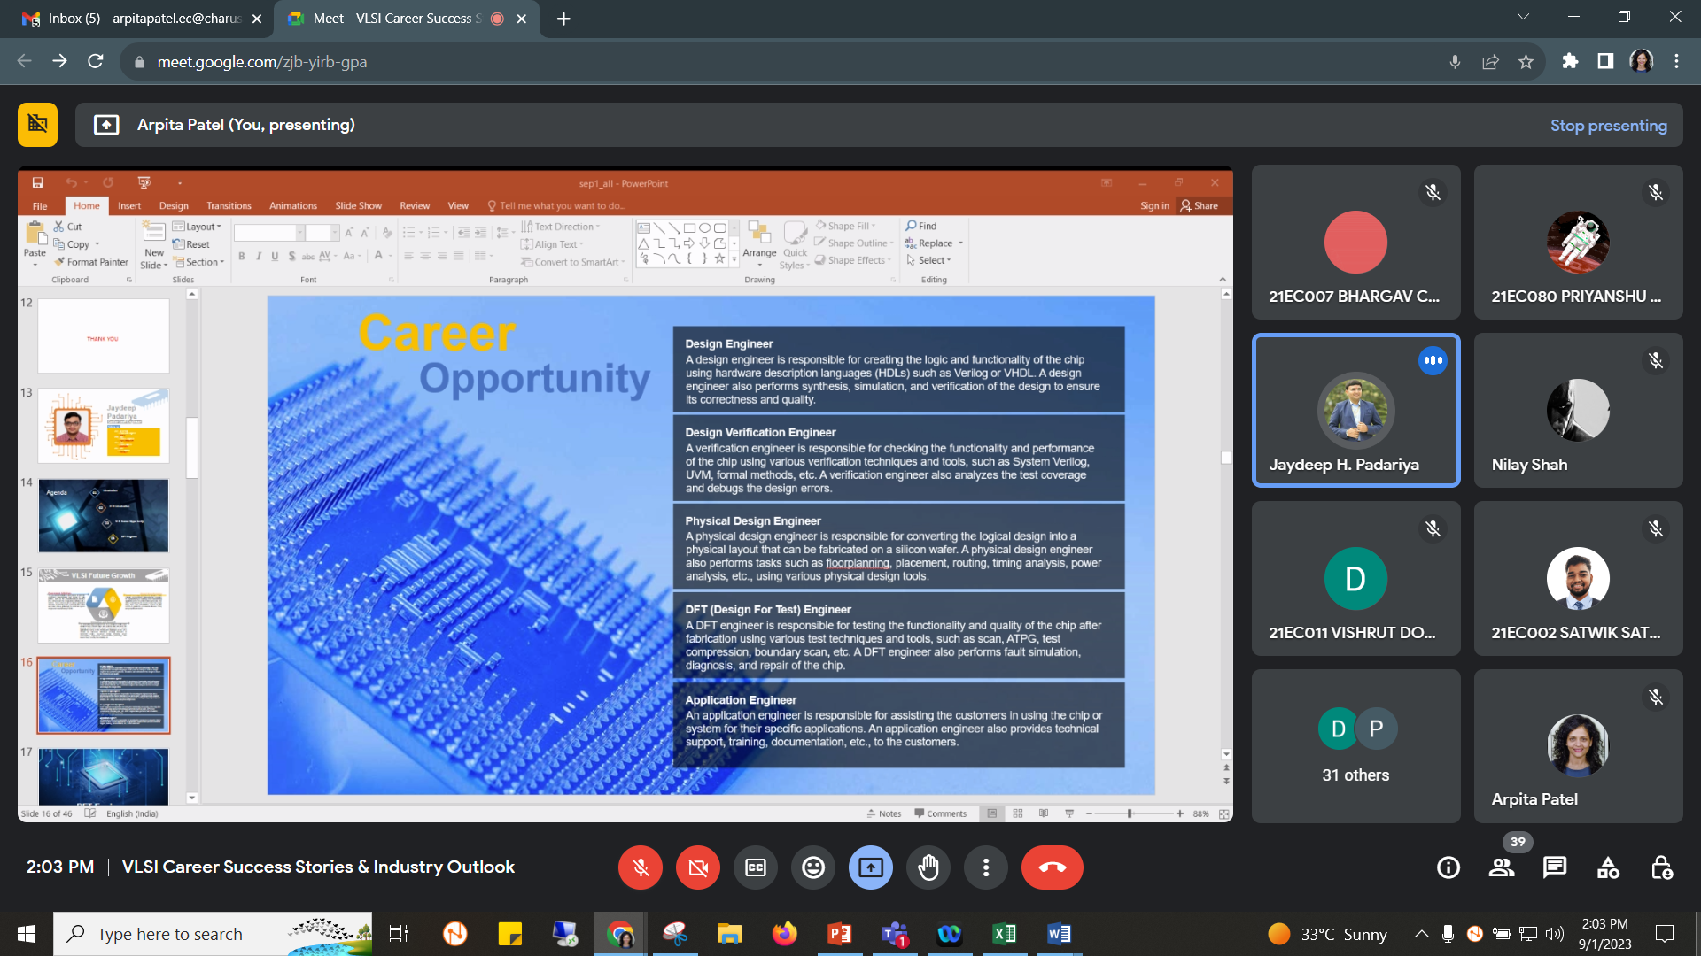

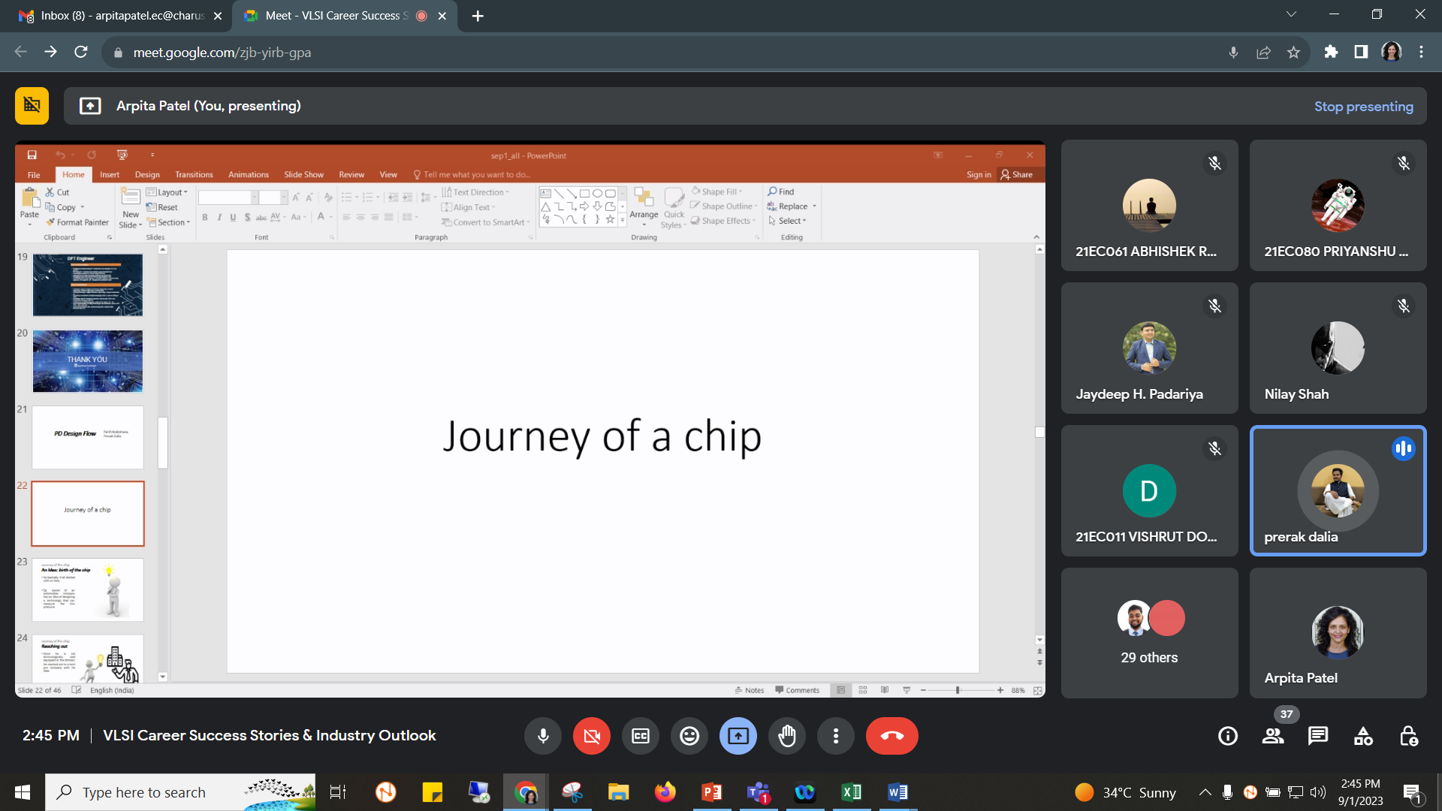

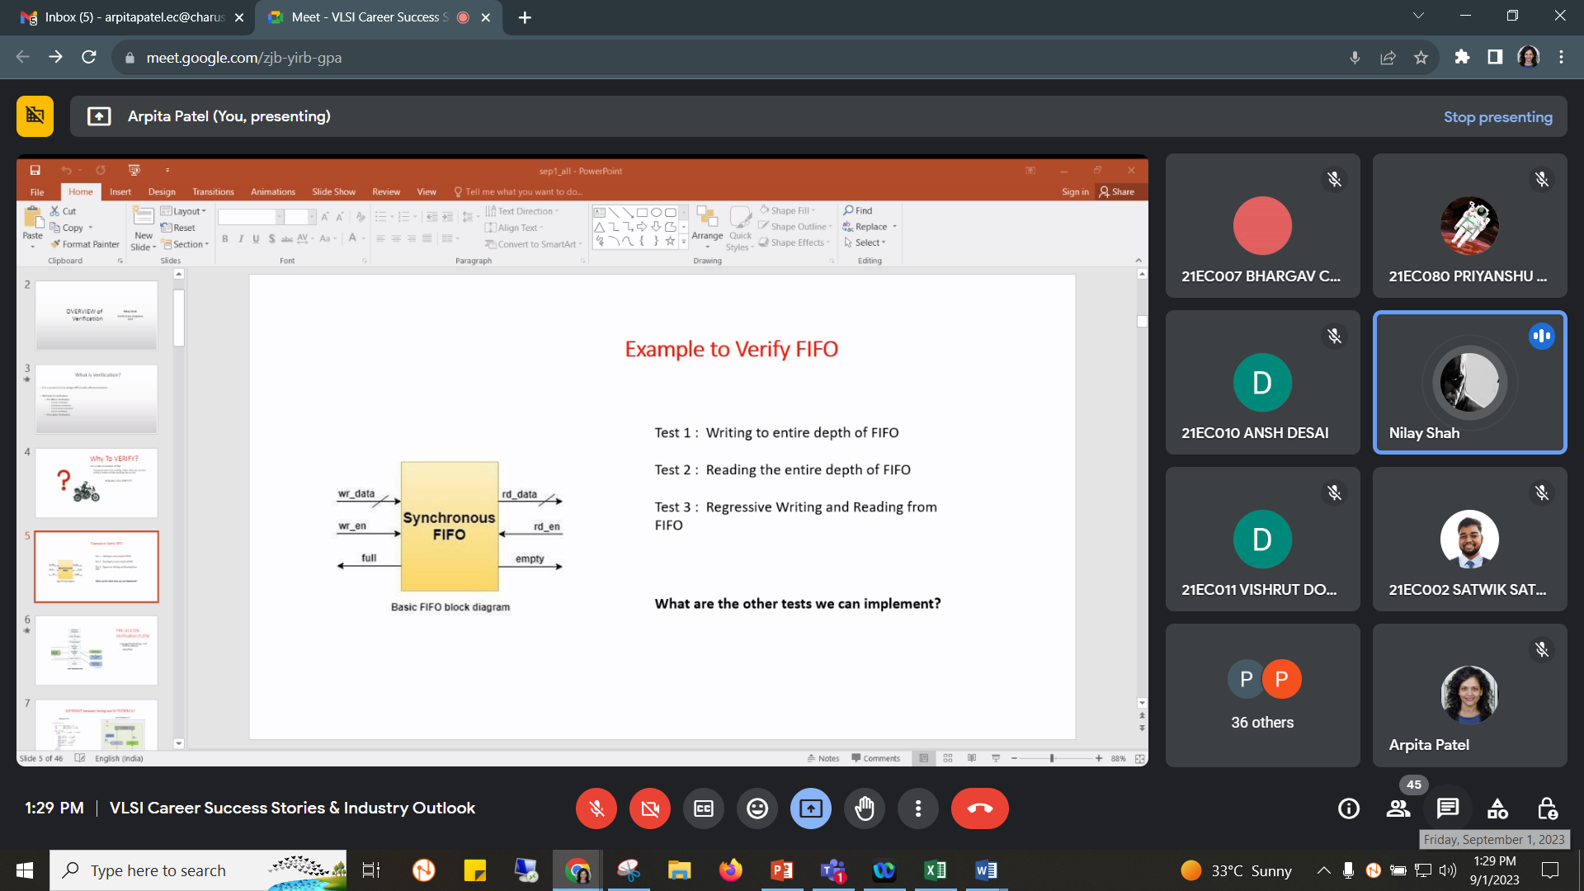

Total Number of students: 45

A**mount sanctioned by CSPIT/CHARUSAT:**

**Accounts details:**

|  |  |  |
| --- | --- | --- |
| **Sr. No.** | **Details** | **Rupees** |
| **Income** | | |
| 1. |  | NIL |
| **Expenses** | | |
|  |  | NIL |
| **Total** |  |  |

**Overall impact of workshop:** Very Good

|  |
| --- |
| **Coordinator Sign:** |
|  |
| **Head of Department Sign:**  **Attendance:** |

